**Lab 3: Controlling a Fan**

**EECE. 4520 Micro­­­­processor II and Embedded System Design**

**0. General Information**

Student Name:

Student ID Number:

Team Name/Number: Team SJK

Team member names: Sua Jung, Julie Dawley, Kyle Purcell

Date of completion: April 18, 2021

Demonstration method: recorded video

**1. Design**

**1.1 Hardware Design**

photo:

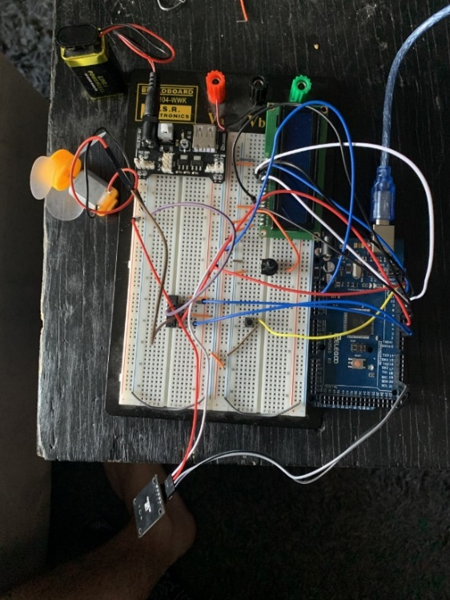

circuit diagram:

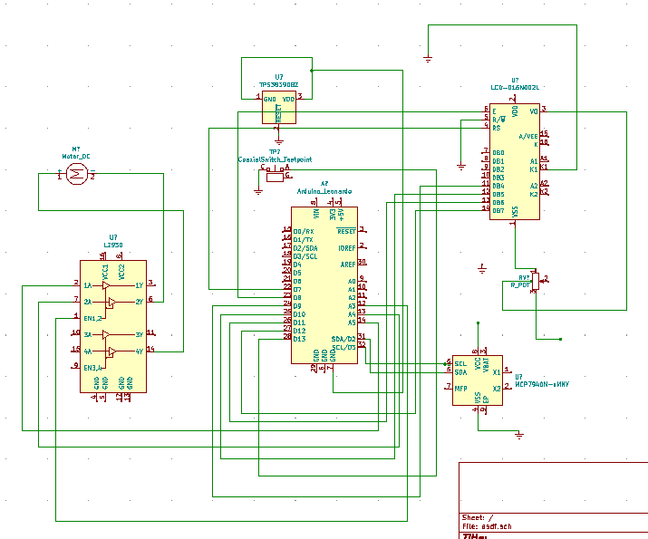

Explanation:

The Arduino connects to L293D, LCD, DS1307, Switch, Power supply and DC Motor. By running the program for fan controller, it can operate as the fan controller and showing the information such as speed, time, and fan directions.

**1.2 Software Design**

**GitHub URL:**

<https://github.com/Kylepurcell10/MicroprocessorsII/tree/main/Lab2>

The GitHub URL contains a public repository that holds the most up to date folder of Lab3 that includes the .ino file and an image of the circuit.

**Pin Assignments:**

Explanation:

**Flow Diagram:**

**1.3 Results**

brief explanation: The circuit functioned properly, and fan controller worked well by the user setting.

video link:

**2. Problem Encountered and Solved**

**3. Personal Contribution to the Lab**

Sua Jung

: Wrote the initial arduino code, debugged the final code, made circuit diagram with KiCad

Julie Dawley

: Debugged the final code, constructed the circuit.

Kyle Purcell

: Wrote the Arduino code, constructed circuit diagram, recorded the photo and video.

**4. Lessons Learnt**

We could understand to make the controller for a fan with DC motor and Arduino programming to complete the fan controller. Using Arduino was helpful to understand the overall flow of the program and how the microcontrollers work all together in the fan controller system. Constructing the circuit diagram to use the components were useful to build the fan controller and also constructing its own system.